
MIS 632 – DATABASE ANALYSIS AND DESIGN FOR BUSINESS
FINAL PROJECT

Students’ Name:
Luan Nguyen
Auspicious Munemo
Bradley Chikwavarara
Benjamin Tawiah
Mirlan Ulanov


Contents
Introduction 3
1. Description of the business operation task for database design. 4
1.1 Business Operation Description 4
1.2 Requirements Analysis 4
Entities and Their Roles 4
1.3 Key Business Rules and Constraints 4
2. Entity Relationship Diagram 5
3. Relational Schema 6
4. Three Business Questions and Their SQL Statements 7
4.1 Fleet Utilization & Revenue Optimization 7
4.3 Customer Behavior & Retention 8
4.2 Operational Risk & Payment Reliability 9
Conclusion 10

Introduction
This report provides a comprehensive understanding of a car rental service’s database management, covering the aspects of customer management, vehicle inventory, reservations, active rentals, and payment processing. Managing these components manually or through disconnected systems introduces significant risk of errors, data redundancy, and operational inefficiency. A proper relational database was designed to address these challenges by establishing clear data structures, enforcing business rules through constraints and relationships, and enabling accurate reporting and decision-making.

The objective of this project is to analyze the operational requirements of a car rental service and translate those requirements into a fully realized relational database. This includes identifying the core entities and their attributes, designing an Entity-Relationship (ER) model, developing a relational schema, and implementing the database in Oracle APEX. The database is populated with sample data and validated through SQL queries designed to answer three meaningful business questions: fleet utilization and revenue optimization, customer behavior and retention, and operational risk and payment reliability.

The following sections present each stage of this process in detail, beginning with the requirements of analysis and data modeling, and concluding with the implemented database and business query results.

Description of the business operation task for database design.

1.1 Business Operation Description
The selected business operation is the Car Rental Service. This system manages the end-to-end process of renting vehicles to customers, from initial reservation through vehicle pickup, active rental, and final payment processing.
In a car rental business, customers browse available vehicles, make reservations for specific date ranges, pick up the vehicle and formally begin a rental, and ultimately pay for the service upon return. The business must track its fleet of vehicles, maintain customer information, manage the lifecycle of reservations and rentals, and record all financial transactions. The database must reliably support this workflow, enforce business rules (e.g., a vehicle cannot be double-booked), and enable management reporting.

1.2 Requirements Analysis

Entities and Their Roles
- Customer - The system must store information about individuals who rent vehicles. Each customer is uniquely identified, and the business needs to retain personal and legal details required for rental agreements and driver verification. Required attributes include a unique customer ID, first and last name, phone number, email address, driver's license number, and date of birth.
- Vehicle - The business maintains a fleet of vehicles available for rental. Each vehicle must be tracked individually by its unique vehicle ID, license plate, VIN, make, model, and year. The system also tracks the daily rental rate, current vehicle status (e.g., available, rented, under maintenance), and vehicle category (e.g., economy, SUV, luxury) to support pricing and availability searches.
- Reservation - Before a rental begins, a customer may place a reservation to hold a specific vehicle for a future date range. A reservation links a customer to a vehicle and captures the intended pickup date and return date. This allows the business to manage scheduling.
- Rental - A rental represents the actual, active use of a vehicle. It is linked to a reservation and the rented vehicle, and records the actual start and end dates and the rental status (e.g., active, completed, cancelled). The distinction between reservation and rental is necessary because a reservation may not always be converted to a rental (e.g., if the customer cancels).
- Payment - Every rental may generate one or more payment records. The payment entity captures the financial transaction(s) associated with a rental, including payment date, amount, payment method (e.g., credit card, cash), a transaction reference, a token reference for secure card processing, and payment status (e.g., pending, completed, refunded).

1.3 Key Business Rules and Constraints
- Each reservation must be associated with exactly one customer; a customer may have zero or many reservations.
- Each reservation is for exactly one specific vehicle; a vehicle may be associated with zero or one reservation over time.
- Each reservation may result in zero or one rental; a rental must be linked back to exactly one reservation.
- Each rental is associated with exactly one vehicle; a vehicle may be associated with zero or one active rental at a time.
- Each rental may generate one or many payments (e.g., a deposit followed by a final charge, or a refund transaction); each payment must belong to exactly one rental.
- A vehicle's status must be updated to reflect whether it is currently available or actively rented.
- The customer's driver's license number and date of birth are required for legal compliance and age verification.

Entity Relationship Diagram
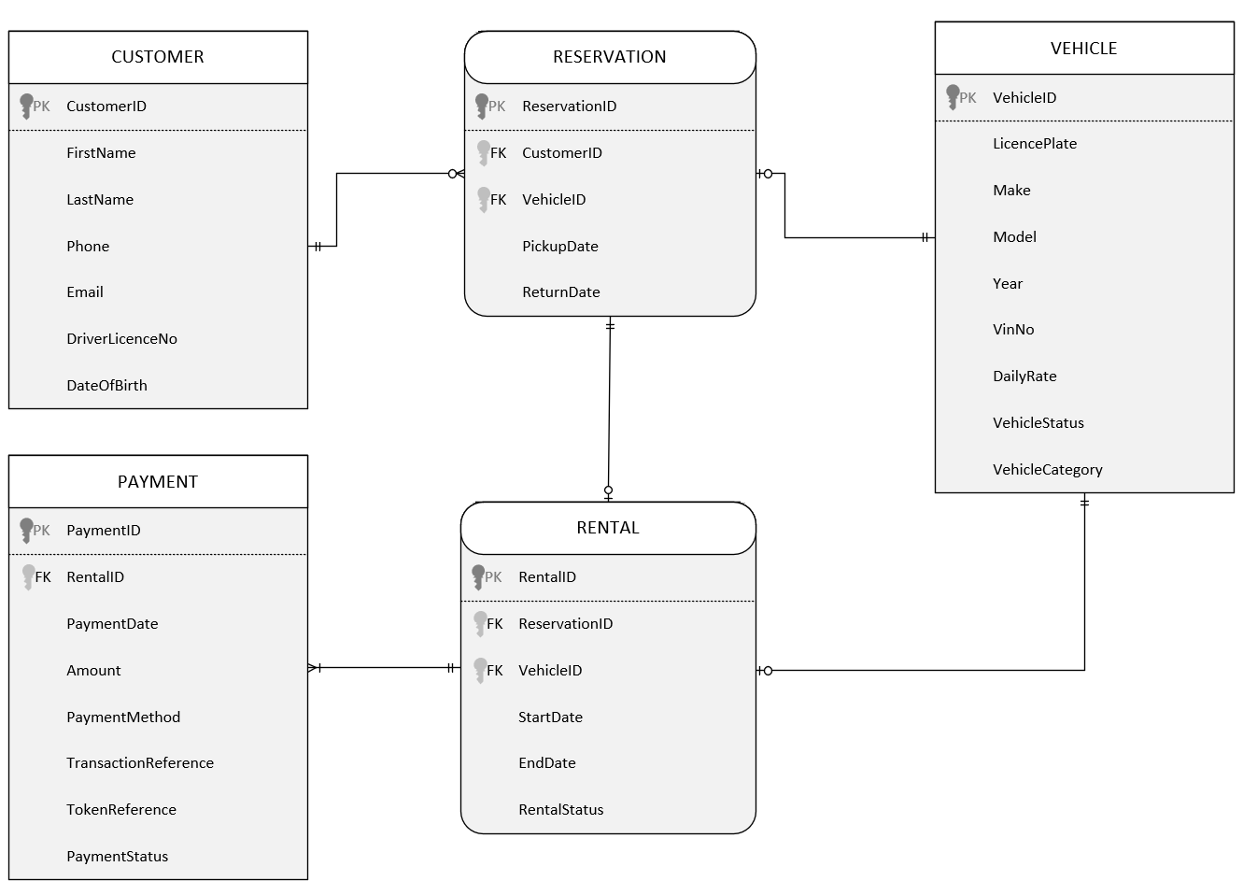

Relational Schema
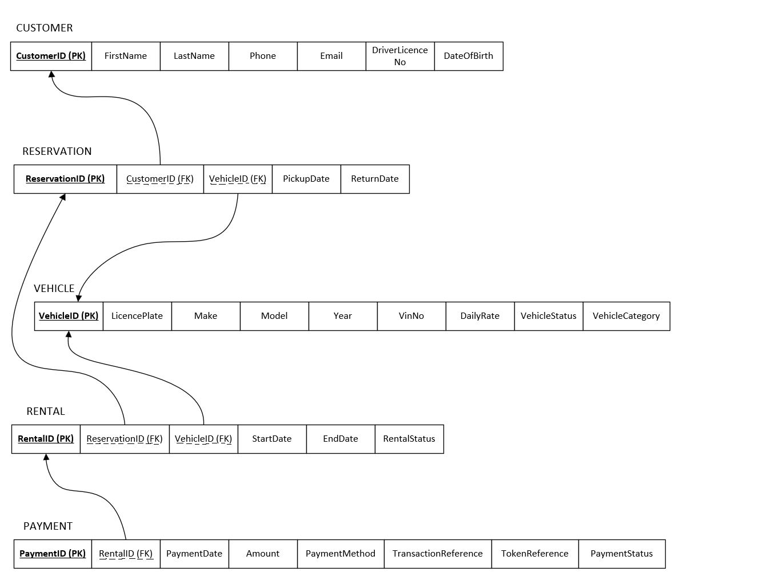

Three Business Questions and Their SQL Statements

4.1 Fleet Utilization & Revenue Optimization
Which vehicles in our fleet are most frequently rented, and which are sitting idle, and how does that impact overall revenue?
This question justifies tracking rentals, vehicle availability, and pricing data in a structured way.

SELECT
v.VehicleID,
v.Make,
v.Model,
v.VehicleCategory,
COUNT(r.RentalID) AS TotalRentals,
NVL(SUM(p.Amount), 0) AS TotalRevenue
FROM Vehicle_T v
LEFT JOIN Rental_T r
ON v.VehicleID = r.VehicleID
LEFT JOIN Payment_T p
ON r.RentalID = p.RentalID
GROUP BY
v.VehicleID, v.Make, v.Model, v.VehicleCategory
ORDER BY
TotalRentals DESC, TotalRevenue DESC;

Insights:

This query successfully retrieves rental counts and total revenue for every vehicle in the fleet, ordered by utilization and revenue to give a clear performance ranking. The results show that the Tesla Model 3 (CAR-2026-0084) leads the fleet with 10 rentals and $6,949 in total revenue, followed closely by the Tesla Model Y (CAR-2026-0079) and BMW X3 (CAR-2026-0023) with 9 rentals each, generating $9,311 and $8,430 respectively. SUVs and Sedans consistently appear among the higher-performing vehicles across both rental frequency and total revenue, suggesting these categories see the strongest customer demand.

The query also highlights an important nuance: rental count alone does not fully determine a vehicle's revenue contribution. The BMW X5 (CAR-2026-0028), for example, produced $5,881 from only 4 rentals, reflecting the impact of a higher daily rate on overall earnings. This distinction between volume-driven and rate-driven revenue is something the database is well-positioned to surface, and it illustrates why tracking both metrics together is more informative than either one alone. Overall, this query gives management a ranked, data-driven view of fleet performance that can support decisions around vehicle availability, pricing adjustments, and future fleet investment.

4.2 Customer Behavior & Retention
Who are our most valuable repeat customers, and what rental patterns (duration, vehicle type, location) define them?
This question justifies storing customer profiles, rental history, and loyalty metrics.

SELECT
c.CustomerID,
c.FirstName,
c.LastName,
COUNT(r.RentalID) AS TotalRentals,
SUM(p.Amount) AS TotalSpent,
ROUND(AVG(r.EndDate - r.StartDate), 0) AS AvgRentalDuration,
v.VehicleCategory AS PreferredCategory
FROM Customer_T c
JOIN Reservation_T res
ON c.CustomerID = res.CustomerID
JOIN Rental_T r
ON res.ReservationID = r.ReservationID
JOIN Vehicle_T v
ON r.VehicleID = v.VehicleID
LEFT JOIN Payment_T p
ON r.RentalID = p.RentalID
GROUP BY
c.CustomerID, c.FirstName, c.LastName, v.VehicleCategory
ORDER BY
TotalSpent DESC;

Insights:

The query produces 87 records across 67 unique customers, combining data from five tables to surface a detailed behavioral profile of each customer. The results show that Gabriel Lopez (LOP1044) tops the spending list with $3,707 from a single 17-day MiniTruck rental, followed by Aurora Reed (REE1082) at $3,063 and Leo Sanchez (SAN1090) at $2,907, both preferring SUVs with average durations of 16 and 17 days, respectively. This pattern makes clear that rental duration is the primary driver of customer value, not frequency. The highest spenders in the dataset are largely one-time renters who chose longer rentals and premium vehicle categories.

SUVs are overwhelmingly the most preferred category, appearing 31 times across customer records, followed by Sedans (20), MiniTrucks (18), and Hatchbacks (18). The fact that some customers appear more than once in the results, such as Leah Price (PRI1063) with 2 rentals, is because the GROUP BY includes vehicle category, meaning customers who rented different types of vehicles appear as separate rows. This is useful for business decisions, as it reveals cross-category rental behavior that could inform bundled promotions or loyalty rewards targeting customers who explore multiple vehicle types.
The average rental duration across all customer records is around 10 days, with a wide range from 1 to 20 days. This spread gives management enough variation to segment customers meaningfully. Short-duration renters may be occasional or business travelers, while long-duration customers represent higher lifetime value and are worth targeting with loyalty incentives to encourage repeat bookings.

4.3 Operational Risk & Payment Reliability
Which rentals are at the highest risk of non-payment or delayed payment, and how do payment patterns vary by rental duration?
This question justifies the need to track payments, rental outcomes, and customer behavior in a structured database because it enables the company to identify high-risk customers, detect risky rental payments, improve revenue protection, and optimize payment methods.

SELECT
r.RentalID, r.ReservationID, r.VehicleID, r.StartDate, r.EndDate, (r.EndDate - r.StartDate) AS RentalDuration,
p.PaymentID, p.PaymentDate,p.Amount,
CASE
WHEN p.PaymentID IS NULL THEN 'NO PAYMENT'
WHEN p.PaymentDate > r.EndDate THEN 'LATE PAYMENT'
ELSE 'ON TIME'
END AS PaymentStatus
FROM Rental_T r
LEFT JOIN Payment_T p
ON r.RentalID = p.RentalID
ORDER BY
PaymentStatus DESC, RentalDuration DESC;

Insights:

The query returns 100 records, one per rental, and the results show an encouraging picture of overall payment health for the business. A strong majority of rentals, 85 out of 100, were settled on time, meaning payment was received on or before the rental end date. Only 15 rentals carry a late payment flag, representing 15% of all transactions. There are no missing payments in the dataset, which confirms that every completed rental resulted in a collected payment.

When looking at the 15 late payments more closely, they span a wide range of rental durations from as short as 1 day (RNT-OYVZ80) to 20 days (RNT-MZTHGX). This tells management that late payment behavior is not necessarily tied to longer or more expensive rentals. Even short, lower-value rentals can slip past the payment deadline, which means blanket assumptions like "only long rentals need chasing" would not be an effective collection strategy.

From a revenue standpoint, the 15 late payments account for a combined $8,775 in delayed revenue, with individual amounts ranging from $61 to $2,179. The highest-value late payment belongs to RNT-MZTHGX, a 20-day rental where $2,179 was collected nearly a month after the rental ended. For a business managing cash flow, having high-value payments arrive weeks late can create real operational strain, even if they eventually come in.

Overall, the 85% on-time rate demonstrates that the current payment collection process is working well for most customers. However, the 15 late cases give management a clear, actionable starting point, as this is exactly the kind of list that could be used to follow up with customers, introduce a deposit requirement at booking, or flag certain rental profiles for closer monitoring on future transactions. Without a structured database tracking this at the transaction level, identifying these patterns would require manual effort across spreadsheets and receipts, making the case for this system's operational value clear.

Conclusion
The project goals were to design and implement a relational database for a car rental service, and the results demonstrate that a well-structured database can effectively support the full operational lifecycle of such a business, ranging from customer registration and vehicle inventory management through reservations and active rentals to final payment processing.

The design process began with a thorough requirements analysis that identified five core entities, including Customer, Vehicle, Reservation, Rental, and Payment. Each entity was carefully defined with its attributes, constraints, and relationships to others, ensuring that the data model accurately reflects how a real car rental operation functions. The resulting Entity-Relationship model and relational schema provide a clean, normalized structure that enforces data integrity through primary keys, foreign keys, and clearly defined cardinality rules.

The database implementation in Oracle APEX brought the design to life, with all five tables created, populated with sample data, and validated through execution. The three business queries developed for this project further demonstrated the practical value of the database. The fleet utilization query showed that the database can rank vehicles by rental frequency and revenue, giving management a clear picture of which assets are performing well. The customer behavior query illustrated how the database can surface loyalty metrics and rental patterns across a customer base, enabling more informed retention strategies. The payment reliability query demonstrated the system's ability to classify and flag payment timing at the transaction level, supporting financial oversight and operational risk management.

Together, these queries confirm that the database is not only structurally sound but also capable of answering meaningful business questions that would be difficult or impossible to address without a properly designed relational system. The project reinforces a key principle of database design that investing in a clear, well-normalized data model at the outset pays dividends in the quality and reliability of the insights that can be drawn from the data over time.

